16th October 2017

**Argentine aces shine in the WTCC**

A heavy downpour at the new Ningbo International Speedpark in China made the FIA World Touring Car Championship race of China a particularly difficult experience. The World Championship which boasts the Japanese Tyre manufacturer YOKOHAMA as Official Tyre supplier, witnessed the Argentinian Esteban Guerrieri as the star performer with a brilliant Opening Race win, before heavy rain forced the Main Race to be stopped on the fourth lap.

His compatriot Néstor Girolami was leading the pack at the time of the red flag and took his maiden World Touring Car Championship victory, while his Polestar Cyan Racing team-mate Thed Björk moved to the top of the title standings by half a point following the WTCC’s first visit to the all-new Chinese circuit.

Success also smiled at Yann Ehrlacher and Nicky Catsburg who completed the Opening Race podium with Norbert Michelisz from the Castrol Honda World Touring Car Team and Björk doing likewise in the shortened second encounter for which half points were awarded.

Guerrieri and Tom Chilton were the winners in the WTCC Trophy.

Honda continues to lead the FIA World Touring Car Championship for the Manufacturers title, while Tom Chilton has moved into the outright WTCC Trophy lead having been tied on points with Mehdi Bennani and Rob Huff before the start.

Competing cars carried #GoTiago18 stickers in support of Tiago Monteiro, the erstwhile championship leader who was forced to miss the race on medical grounds following his testing accident in Spain last month.

The FIA WTCC will visit Japan’s Twin Ring Motegi for the next rounds on the 27th -29th October.

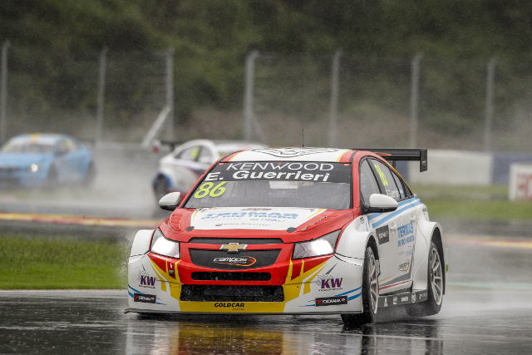

*Guerreri Wins Opening race in China WTCC*

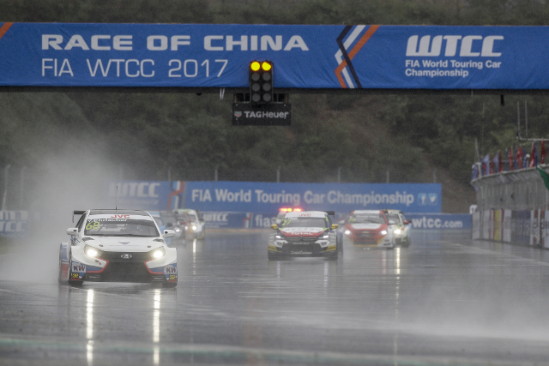

*Heavy Rain forced to stop the Main Race*